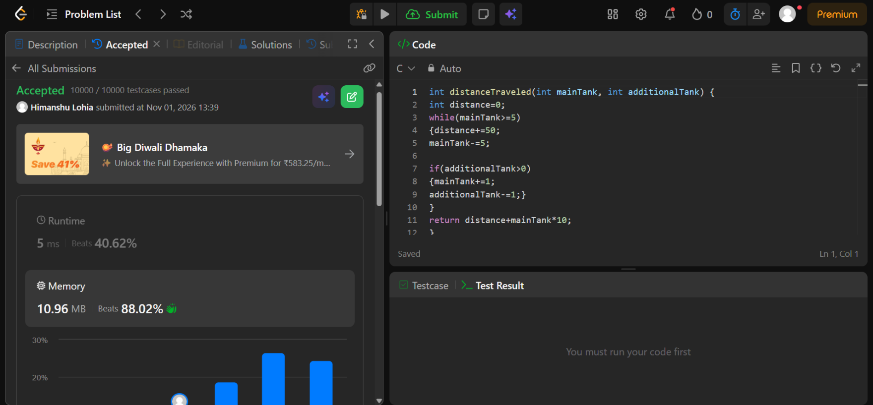
https://leetcode.com/problems/total-distance-traveled/submissions/2186828578/

int distanceTraveled(int mainTank, int additionalTank) {
int distance=0;
while(mainTank>=5)
{distance+=50;
mainTank-=5;

if(additionalTank>0)
{mainTank+=1;
additionalTank-=1;}
}
return distance+mainTank*10;
}

